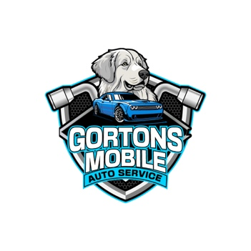
Disclosure Agreement
Scope of Services: Gorton’s Mobile Auto Service provides mobile mechanic services, including but not limited to vehicle diagnostics, general maintenance, and minor repairs. The services will be performed at the customer’s specified location. Gorton’s Mobile Auto Services does not provide major engine repairs, transmission replacements, or services requiring specialized equipment beyond mobile capability.
Liability Disclaimer: The customer acknowledges that mobile mechanic services are performed to the best of Gorton’s Mobile Auto Service’s ability based on the condition of the vehicle at the time of service. Gorton’s Mobile Auto Service is not responsible for
- Any pre-existing issues, hidden damage, and prior repairs affecting the vehicle.
- Damage resulting from continued vehicle operation post-service if the customer fails to follow recommendations.
- Any damage or injury caused by third-party parts or components installed at customer’s request.
- Any personal injury or property damage caused by the vehicle before, during, or after service.
- Any damage, or personal property to the vehicle before, or after service is completed.
- No services will be done on vehicles that the owner negligent.
- No work will be done if customer supply the parts, all parts must be supplied by the mechanic to assure proper fit.
- The mechanic is required to ensure all proper information such as (Name, Phone number, Address, Vehicle Vin, License Plate Number).
- The mechanic is also required to take pictures of any damages or concerns of the vehicle throughout the service.
Warranty Policy: Gorton’s Mobile Auto Service offers a warranty of 60 days on labor for repairs performed. Any warranty claims must be reported within this period. Parts warranties, if applicable, are subject to the manufacturer’s terms. This warranty only covers workmanship, does not cover misuse, accidents, or wear-and-tear. Gorton’s Mobile Auto Service has the right to accept or deny warranty claims.
Parts and Third-Party Responsibility: The mobile mechanic is not responsible for delays caused by third-party suppliers or parts manufactures.
Video and social media Policy: Gorton’s Mobile Auto Service may post videos and pictures of customers vehicles on social media for promotion and advertising. Posts will only provide pictures of vehicle, surroundings, and work being performed. No personal information such as (license plate number, VIN, etc.), or discrimination will be posted at any point.
Customer Responsibilities:
- The customer must ensure the vehicle is parked in a legal, safe, and accessible location for service.
- The customer agrees to disclose all known issues with the vehicle before service begins.
- The customer understands that mobile repairs are limited by available tools and environmental factors.
- The customer acknowledge that additional repairs may be necessary and that they are responsible for any associated cost.
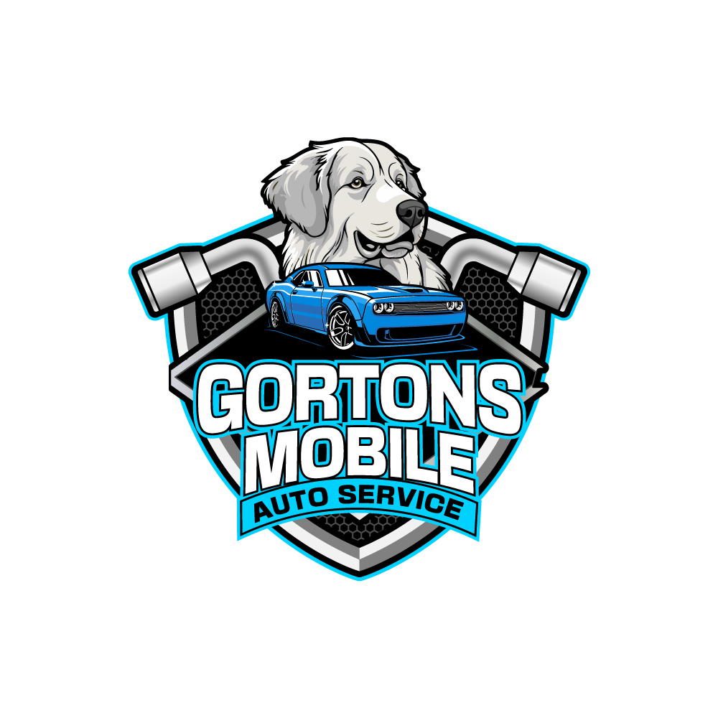
- The customer is responsible for obtaining necessary permits or permissions for service performed in restricted locations (e.g., apartment complexes, private property, etc.).
Payment Terms:
- Full payment is required upon service completion, keys will be kept by the mechanic until payment is made in full.
- Any disputes regarding service quality must be reported within 24 hours.
- Accepted payments methods: (Cash, Credit Card, Financing)
- On services with higher cost will be required for half payment up front before work starts.
- The mechanic also has the right to ask for payment up front on some circumstances.
Deposit Policy:
- A deposit will apply if parts must be ordered or in advance parts ordering. All deposit will be applied towards the final service cost.
Service Cancellation Policy:
- Cancellations must be made at least 24 hours in advance to avoid a cancellation fee of $60.
- If a customer is not present at the scheduled service time, a no-show fee of $80 may apply.
- Emergency cancellations due to weather or unforeseen circumstances will be rescheduled at no penalty.
- If Gorton’s Mobile Auto Service is unable to complete the service, the client will receive a refund for any prepaid services not preformed.
- Mechanic can cancel the job at any time if he feels unsafe.
Indemnification and Insurance: The client agrees to hold Gorton’s Mobile Auto Service harmless from any claims related to services performed, except in cases of proven negligence. Gorton’s Mobile Auto Service LLC confirms they hold all necessary insurance required.
Consent and Signature

I, ____________________________________, acknowledge that I have read and understood the terms of this Mobile Service Disclosure Agreement. I agree to the conditions outlined above and consent to proceed with the requested services.

Customer Signature: _______________________________________

Date: __________________

Gorton’s Mobile Auto Service reserves the right to update this disclosure agreement at any time. Customers will be notified of significant changes before service if provided.

